Green Society Public School
D-11
Ratnanagar-7, Sauraha, Chitwan
Annual Examination-2082
Class: Nursery Time: - 2 hrs. F.M.: 50
Sub: Maths ‘W’
Name: Roll No.: Sec.:
________________ ______________ OBT.MARKS:
INVIGILATOR EXAMINER
1. Count and circle the numbers. 5

: 8 7 2










: 11 10 9

: 5 16 13






: 12 6 15
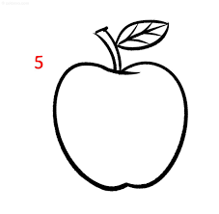






: 7 4 3

2. Match the number with numbers name. 5
1 Five
5 One
4 Two
10 Four
2 Ten
3. Write the Devanagari numbers (!%–@)_. 5
!%
4. What comes after? 6
2 10 21
29 14 9 _
5. Circle the Devanagari number of '!*'. 5
!* !*
( # !* *
!* !*
%

6. Count and write. 5

:

:
:

:





:

7. Write the missing numbers. 7
1 4, 5 7 9 12 14, 15.




8. Colour the odd one pictures. 5
1.
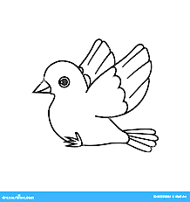
2.

3.


4.

5.
9. Match the same shapes. 3

10. Write the numbers name. 4
1: 2:
The End

